/Users/albertoguzman-alvarez/Box Sync/CEE Educational Analytics/CEE Logos/CEE Logo/CEElogo.pdf

Washington Program

2006-2017 Quantitative Landscape Analysis

July 15, 2016

Alberto Guzman-Alvarez & Hannah Kosinovsky

Introduction

The Washington Program (WP) is an internship program run out of the Office of Undergraduate Education at UC Davis. The WP provides undergraduate students the opportunity to have a professional internship in the Washington D.C. Metro area. During the 15-16 academic year the Washington Program approached CEE with a request for a landscape analysis of their program, the following report presents the findings of that analysis.

Sample

CEE was provided with the data of 2,078 students who had either applied to be in WP or were accepted and completed the program. Data was included for students going back to 2006, a few students appear in the upcoming 16-17 academic year because of the recruitment and placement strategy of WP.

Research Questions

The following research questions were established after CEE team members and the Director of the Washington Program met to discuss the objectives of the analysis.

1. Who is being recruited and applying to the Washington Program?
2. Who is being accepted into the Washington Program?
3. Does the Washington Program have an effect on students’ graduation?

Analysis

In order to analyze the previous questions a landscape analysis was undertaken by the CEE team. This included appending relevant demographic information about students to the original dataset, running descriptive statistics, and statistical modeling. All the analysis was conducted using the R statistical program.

*Who is being recruited and applying to the Washington Program?*

Between 2006 and 2016 a total of 2,708 students applied to be a part of the WP. Once a student applied one of seven determinations was granted to a student; Approved, Deferred, Denied, Dropped, Pending, Submitted, and Waitlisted. Figure 1 shows a breakdown of determination by year.

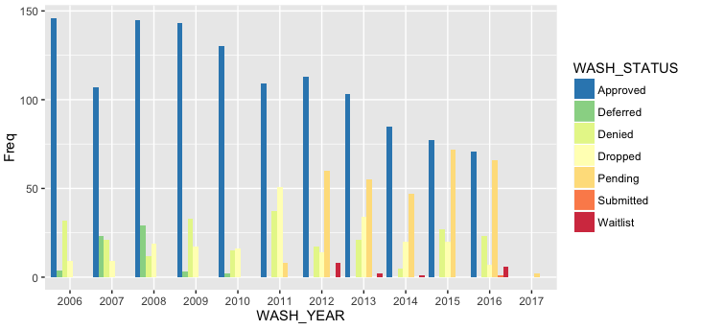

Figure 1. Washington Status by Academic Year

The WP appears to have had a steady decline in the amount of students accepted into the program, as well as varied acceptance patterns. At the peak the WP was accepting close to 150 students but by 2016 that number has dropped to 77 students. It also appears that no one is getting deferred after 2010, perhaps admission practices have changed for the WP program since then.

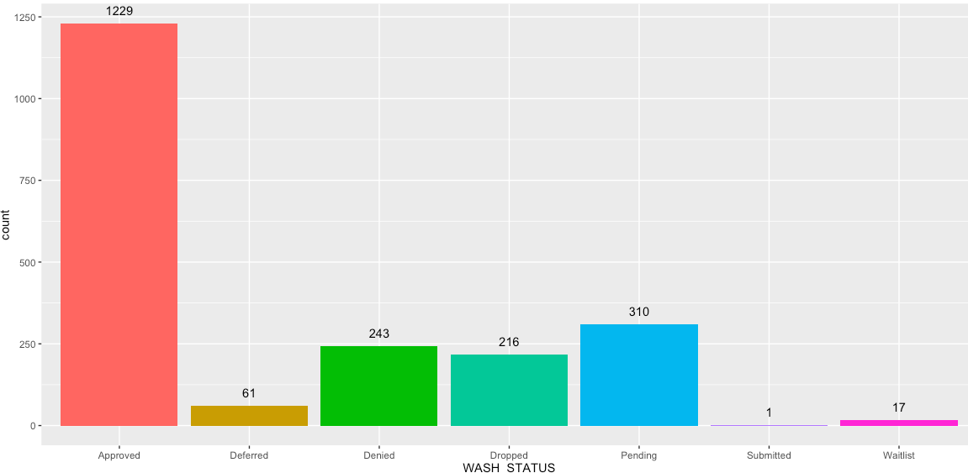

Figure 2. Washington Status Overall

Figure 2 above shows the Washington Program determination for the entire sample of students who applied. The WP has an overall acceptance rate of 59%, a small percentage of 11% are denied admission into the program. Very few students are deferred or put on a waitlist.

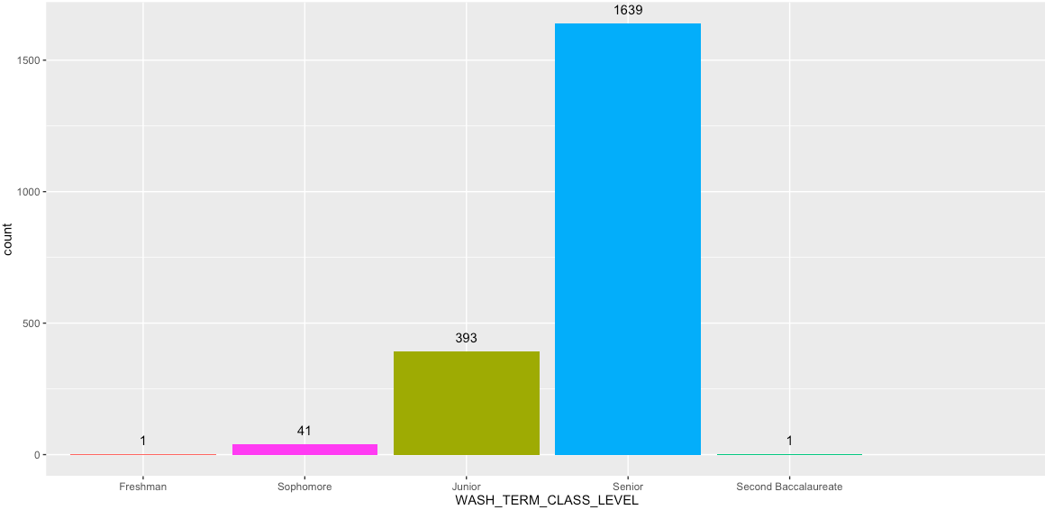

Figure 3. Washington Program Applicants by Class Standing

Students who applied for the WP are almost exclusively upper classmen, 98% of them are either Juniors or Seniors (Figure 3). The program does not seem to be attracting/recruiting freshman or sophomore students.

**Demographic descriptives for entire WP sample:**

|  |  |
| --- | --- |
| **Variable** | **Percent** |
| Low Income | 31.2% |
| International | 2.5% |
| Transfers | 24.5% |
| Female | 68.8% |
| URM | 26.0% |
| First Generation | 31.2% |
| STEM Major | 24.7% |

A demographic view of the WP applicants shows that they are attracting women (69%) and students who come into UCD as freshman (76%). Applicants are more likely to be Non-URM, Non-First Generation, and be Non-STEM. This is likely due to a mix of smaller samples of URM and FG in the overall UCD population and that people belonging to traditionally low-SES groups perhaps might not have the means to pay for the WP cost on top of normal tuition.

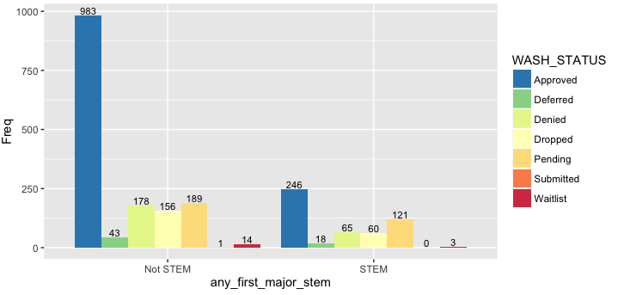

Figure 4. Washington Program STEM vs. Non-STEM Major

One of the variables of interest for the WP was a students major and discipline. The WP program attracts a large proportion of Non-STEM majors. This is not surprising given the fact that the WP by design would attract students who are in non-stem fields given DC’s focus on government, political science, and social sciences.

In order to provide more detail students actual major was analyzed. Since there are hundreds of majors a student can have, the analysis focused on majors with more than 1%, listed below.

**Major titles with over 1% acceptance (decreasing order):**

|  |  |
| --- | --- |
| **Major** | **Percent** |
| Political Science | 14.8% |
| International Relations | 9.6% |
| Economics | 4.0% |
| Communications | 3.2% |
| History | 3.1% |
| Psychology | 2.8% |
| Agricultural Management | 2.7% |
| Sociology | 2.3% |
| Public Service | 1.5% |
| Community and Regional Development | 1.4% |
| English | 1.4% |
| Environmental Policy Analysis | 1.2% |

Not surprising the majority of students who applied to the WP were political science majors, followed by International Relations, and Economics. The majority of students come from the College of Letters and Science, followed by the College of Agriculture. Most of the majors that apply are humanities majors but there are some that are more Economics/Business related.

**Discipline titles with over 1% acceptance (decreasing order):**

|  |  |
| --- | --- |
| **UCD Discipline** | **Percent** |
| Social Sciences (GRSOC) | 50.6% |
| AES - Human Sciences (HUMSC) | 9.0% |
| Humanities, Arts (GRHMN) | 4.2% |
| Biological Sciences (GRBIO) | 4.1% |
| AES - Environmental Sciences (ENVSC) | 3.0% |
| Engineering (ENGIN) | 1.1% |

The table above breaks down a student’s academic discipline. The WP seems to be attracting a large proportion of Social Sciences students, followed by Human Sciences, and Humanities and Arts. As mentioned above this is not surprising given the focus of the WP.

*Who is being accepted in to the Washington Program?*

Of the 2,078 students that applied to the WP, 59% of them were accepted (n = 1,229). As previously mentioned the WP has had a steady decline in the number of students that were accepted (Figure 5). This may be due to budgetary reasons of the WP as discussed with the WP program director.

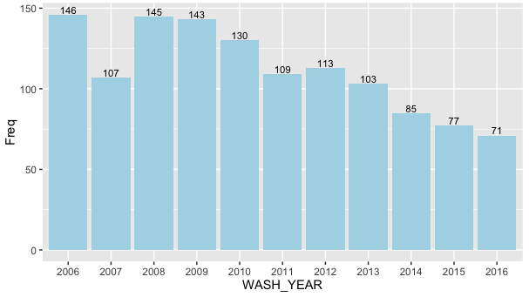

Figure 5. Washington Program Accepted Students

Figure 6 shows the class standing of students who were accepted into the WP. Students who were accepted for the WP are almost exclusively upper classmen, 98% of them are either Juniors or Seniors, there was one student who was receiving their second bachelor’s degree.

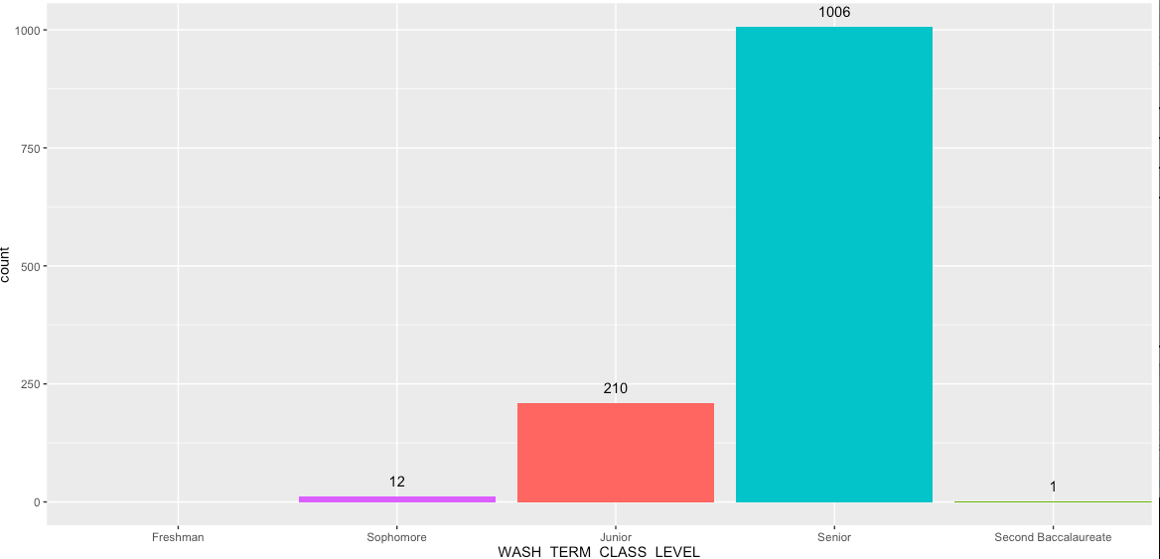

Figure 6. Washington Status Accepted Students Only

**Demographic descriptives for accepted WP sample:**

|  |  |
| --- | --- |
| **Variable** | **Percent** |
| Low Income | 30.9% |
| International | 1.5% |
| Freshman Starts | 79.8% |
| Female | 69.1% |
| URM | 25.3% |
| First Generation | 30.9% |
| STEM Major | 20.0% |

Students who are accepted into the WP are more likely to be women (69%), Non-URM (75%), Non-FG (69%), and not considered low-income (69%). Accepted students predominantly come from non-STEM majors. The following figures summarize the demographic findings.

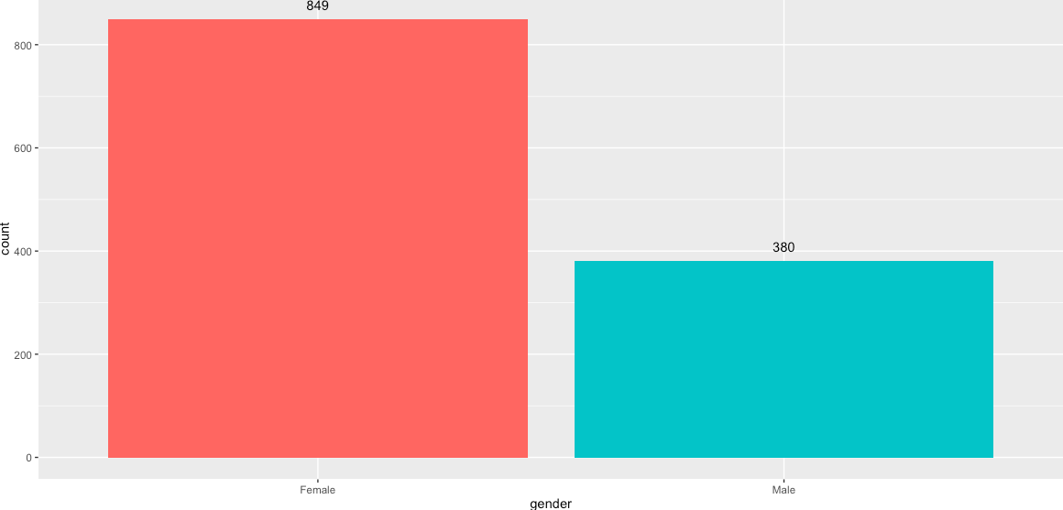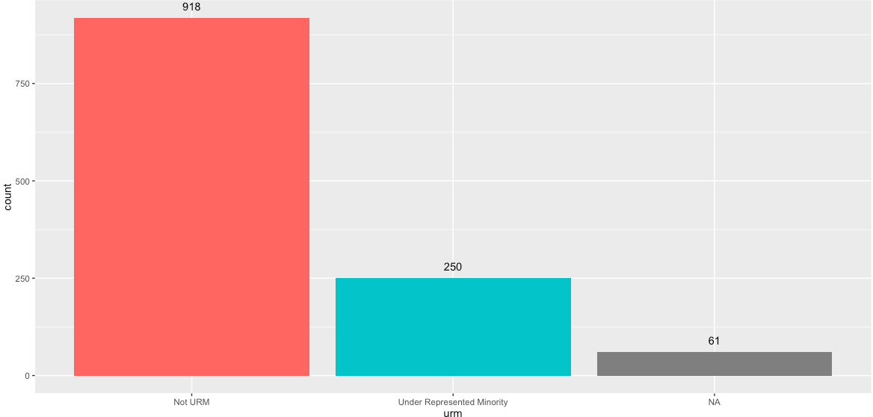

Figure . Gender Figure 8. URM

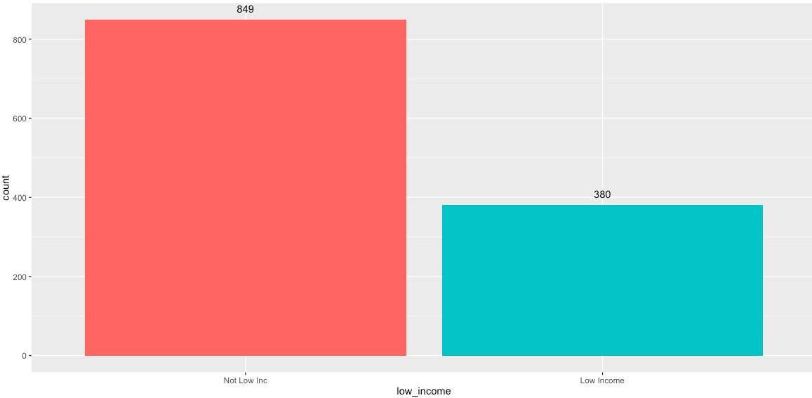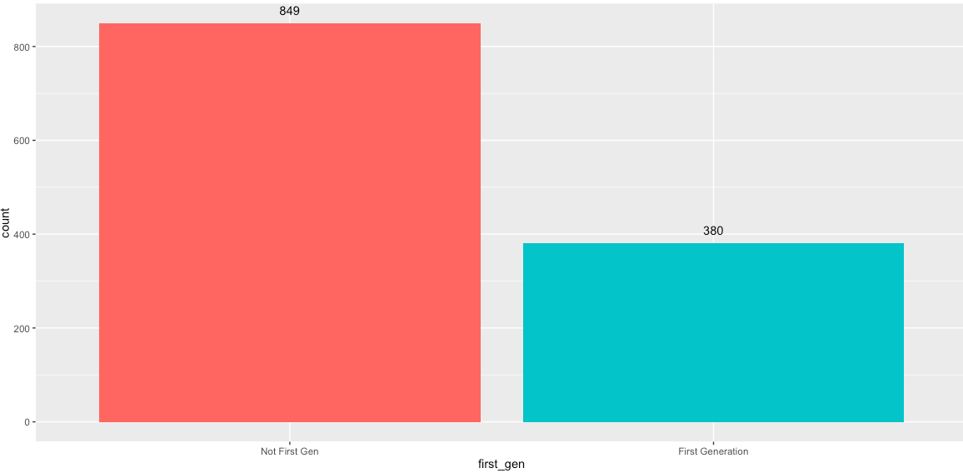

Figure . Low Income Figure . First Generation

In regards to academic majors the WP program attracted a large proportion of Non-STEM majors. The majority of students who were accepted to the WP were political science majors (25%), followed by International Relations (16%), see Figure 11.

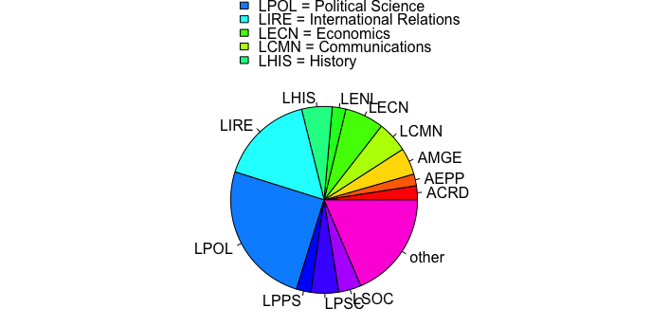

Figure 11. Washington Program Majors Accepted

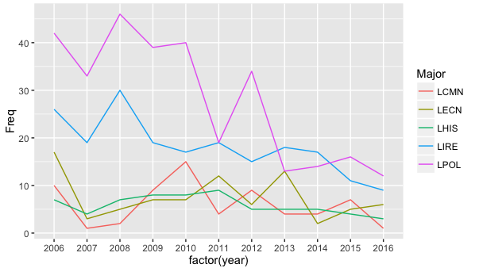

Figure . Washington Program Top 5 Major Trends

Figure 12 shows the trend for the top five majors that are accepted into the WP. The fluctuations of History, Communication, and Econ are fairly even. It appears that Political Science majors have had a decline since their peak in 2008, there is also a similar trend for IR students. This is likely due to declining number overall in the number of students that the WP is able to accept.

*Does the Washington Program have an effect on student’s graduation?*

In order to effectively answer this questions, the analytical sample of students who were accepted into the WP (n = 1,229), was reduced to students who were capable of graduating based on their UCD enrollment year. For example, if a student was admitted during the 15/16 school year this student would not have had enough time to graduate at the time of this analysis, therefore they were dropped. Both 4-year, 5-year, and 6-year graduation rates were calculated. The final analytical sample of students who were in the WP and had adequate time to graduate between four to six years was 1,069 students.

Of the 1,069 students 902 students had adequate time to graduate in four years based on their admissions terms. A total of 765 of those WP students graduated within 4-years, leading to a 4-year graduation rate of 84.8%. In regards to 5-year graduation rates, a total of 1059 students has adequate time to graduate in five years, 1,049 of those students did so, leading to a 5-year graduation rate of 99.1%. The final 6-year graduation rate for the WP is 99.8%.

Students who were accepted into the WP were very likely to graduate, this of course can’t be attributed to the WP itself, it is most likely a range of experiences that attribute to a student having a higher chance of graduating. To fully answer this question a more robust analysis with a control group would be needed.

Conclusion

The Washington Program is able to provide an excellent opportunity to hundreds of undergraduate students at UC Davis. Since the year 2006, many students have shown interest in the program by applying (n = 2,087). Although the program has declining numbers in the amount of students its able to accept, the WP has accepted 1,229 students. Those students were predominantly female students who had non-STEM related majors. The WP seems to attract students who are less socio-economically diverse, meaning they are more likely to be non-URM, non-FG, and non-low income. This is likely due to the WP extra cost on top of regular tuition, this cost may drive away students who might not have the financial means of funding their program.

This landscape analysis should serve as a “snap shot” of the Washington Program, showing who is applying and who is getting accepted. A more robust analysis may be needed if the program administrators hope to see if the program leads to statistical changes in a students’ outcomes.